======================================================================
GENERATING CUSTOMER DEMANDS
======================================================================
Total customers : 21
Small customers : 13 (61.9%)
Large customers : 8 (38.1%)

======================================================================
FINAL CUSTOMER DEMAND ASSIGNMENT
======================================================================
Customer Demand Weight Drone
--------------------------------------------------
85 47.0 3.133 LARGE
86 33.0 2.200 SMALL
94 61.0 4.067 LARGE
95 64.0 4.267 LARGE
98 25.0 1.667 SMALL
99 32.0 2.133 SMALL
100 19.0 1.267 SMALL
101 59.0 3.933 LARGE
102 56.0 3.733 LARGE
207 26.0 1.733 SMALL
209 20.0 1.333 SMALL
210 49.0 3.267 LARGE
211 25.0 1.667 SMALL
212 22.0 1.467 SMALL
215 32.0 2.133 SMALL
218 36.0 2.400 SMALL
219 60.0 4.000 LARGE
222 22.0 1.467 SMALL
223 33.0 2.200 SMALL
224 28.0 1.867 SMALL
225 50.0 3.333 LARGE

======================================================================
DEMAND GENERATION COMPLETED
======================================================================
Output file : customer_demands_k6.pkl
Total : 21
Small : 13 (61.9%)
Large : 8 (38.1%)
Scale factor: 15.0
Small capacity: 2.7 kg
Large capacity: 6.0 kg

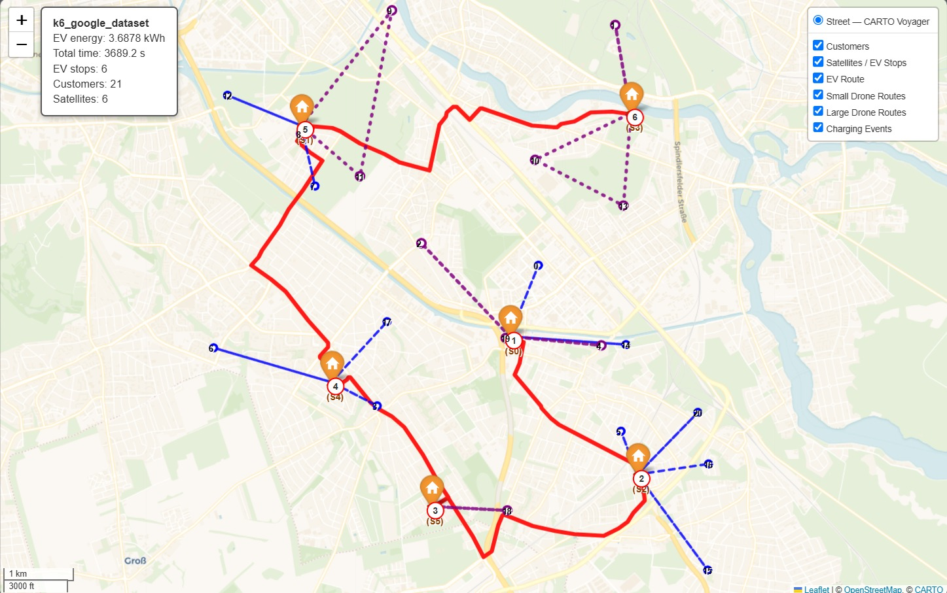

Real-World Geographic Implementation
The objective of incorporating real-world geographic information is to evaluate the practical applicability of the proposed energy-minimizing two-echelon routing framework under realistic transportation conditions, where electric vehicles (EVs) are constrained by road networks while drones can travel directly between delivery locations. This implementation extends the proposed approach beyond an abstract distance-based network and enables the optimized EV and heterogeneous drone routes to be evaluated and visualized in an actual geographical environment.
As a first step, the customer demands are converted into payload weights to support the heterogeneous drone assignment. A total of 21 customers are considered, with approximately 60% assigned to the small drone and 40% to the large drone. The demand values are converted into payload weights using a scale factor of 15. Customers with a payload weight up to 2.7 kg are considered eligible for the small drone, whereas customers with a payload weight greater than 2.7 kg and up to the maximum capacity of 6.0 kg are assigned to the large drone. Accordingly, the considered instance contains 13 small-drone customers (61.9%) and 8 large-drone customers (38.1%). This two-category load assignment enables the routing framework to account for the heterogeneous payload capacities when constructing the drone delivery routes.
The original abstract network is then adapted to represent the actual geographic environment by associating the satellite and customer nodes with their corresponding GPS latitude–longitude coordinates. The distance representation is also modified according to the operational characteristics of the transportation modes. Since the EV operates through the road network, the distance between satellite locations is obtained from Google Maps road-network distances. In contrast, drones are not restricted by road infrastructure and therefore travel directly between locations; consequently, the distances between satellites and customers and between customer locations are represented using direct aerial distances. Thus, the EV and drone components of the routing framework employ distance measures that reflect their respective modes of transportation.
The geographic information is incorporated without changing the fundamental optimization structure of the proposed routing framework. The optimization process determines the EV sequence of satellite visits together with the assignment and routing of small and large drones. After obtaining the optimized solution, the corresponding satellite and customer identifiers are linked back to their original geographic coordinates. This enables the optimized network solution to be reconstructed as actual geographic trajectories while retaining the operational characteristics of the proposed EV–dual-drone system.
The resulting solution is subsequently visualized on a real geographic map to demonstrate the spatial behaviour of the proposed routing framework. The red route represents the road-network path followed by the EV among the six satellite/EV stops, whereas the blue dashed routes and purple dotted routes represent delivery sorties performed by the small and large drones, respectively. Customer locations are represented as numbered nodes, while the satellite locations are indicated by orange markers, representing the points from which drone operations are initiated and completed. A drone sortie may serve either a single customer or multiple customers depending on the corresponding routing and payload constraints. For the obtained solution, 21 customers are served through 6 satellite stops, with a total EV energy consumption of approximately 3.6878 kWh and a total operational time of 3689.2 s. The resulting geographic representation demonstrates how the proposed optimization framework coordinates the EV and heterogeneous drones over an actual spatial network and provides a practical interpretation of the optimized routing solution.

